Fixed Income Securities

Group Project – Option A

Authors:

Luís Ribeiro (nº 20231536)

Renato Morais (nº 20231135)

Fernando Tiago (nº 20231535)

Thiago Bellas (nº 20231131)

Contents

Introduction 3

Exercise 1 – Capital Indexed Inflation Linked Bond 4

Task A – Compute accrued interest 5

Task B – Simulate 10000 scenarios of the CPI index 7

Task C – ILB cash-flows/fair value for each scenario 9

Task D – Estimate and analyze the ILB price distribution, including interest rate and inflation risk measures 14

Price distribution 14

Interest Rate Risk measures 15

Exercise 2 – Hedging Portfolio 18

Task A – Compute the level, slope, and curvature durations and dollar durations of the target portfolio 19

Task B – Compute level, slope, and curvature durations and dollar durations 21

Task C – Estimate the holdings of the hedging portfolio assuming the hedger wants to implement a self-financing hedging strategy 22

Task D – Assuming that the yield curve changed 25

Part 1 – With no hedging strategy 25

Part 2 – With hedging strategy 26

Conclusions 27

# Introduction

This analysis delves into the comprehensive evaluation of an inflation-linked bond (ILB) and the development of a corresponding hedging strategy aimed at managing interest rate risk effectively. In examining the ILB, we focus on crucial aspects such as accrued interest calculation, simulation of inflation scenarios, and analysis of cash flows to understand variability influenced by inflation and interest rates. Additionally, we conduct bond price distribution analysis to assess interest rate risk using a specific methodology.

In parallel, we develop a hedging strategy involving sensitivity analysis of hedging instruments and portfolio metrics. Optimal hedge ratios are computed to mitigate risk effectively, and results include key metrics such as level, slope, and curvature durations, along with dollar durations for comprehensive risk assessment.

Furthermore, we evaluate the impact of changes in the yield curve, both with and without the hedging strategy. Visualizations and calculations demonstrate the effectiveness of the hedging strategy in mitigating losses associated with yield curve shifts. This analysis underscores the critical importance of robust risk management strategies in investment portfolios, particularly when dealing with complex financial instruments like ILBs. By integrating historical data, future projections, and risk assessments, investors can make informed decisions to optimize portfolio performance and minimize potential losses in dynamic market conditions.

# Exercise 1 – Capital Indexed Inflation Linked Bond

In this first exercise, we are given a term sheet for a Capital Indexed Inflation Bond (ILB) with the following term sheet:

Since this is a Capital Index ILB, we are dealing with two types of inflation adjustment: notional adjusted to the inflation index ratio (Capital Index); and the cash-flows adjusted to the inflation index ratio (ILB).

In this case, we are given two CPI indices for settlement and issue dates. These will be useful for forecasting and index ratio adjustment, respectively.

For the forecasting, we are going to use a Geometric Brownian Motion (GBM) with a diffusion coefficient and .

For the yield curve, we are given a Nelson-Siegel-Svensson set of parameters:

## Task A – Compute accrued interest

The accrued interest of a bond is the interest accumulated from the last coupon up until the settlement date. Before calculating it, we need to account for inflation using the Index Ratio, which in this case will be the settlement CPI divided by the issue date CPI, giving us 1.0590, indicating an increase of approximately 5.9% in the Consumer Price Index (CPI) between the issuance and settlement of the bond.

The accrued interest value before the first coupon payment date was determined by considering the time elapsed from the issuance date to the settlement date. However, due to the semiannual coupon payment structure with payment dates on 21/1 and 21/7, the first coupon is prorated based on the time elapsed from the issuance date to the settlement date.

In this case, there was no previous coupon up until the settlement date, so we will compute the accrued interest from the issue date.

For better calculations, we have resorted to using QuantLib and defining the following functions which will also be used later:

Finally, we reach the result seen below:

Note: the real accrued interest is simply the accrued interest adjusted for inflation.

## Task B – Simulate 10000 scenarios of the CPI index

Even though not the most correct technique, we have simulated the CPI index, using the settlement date CPI index and then forth with the given coefficients, for each month since the US CPI is updated monthly. The indices are then “interpolated” later.

Here is a snippet of code for simulating the 10000 scenarios of the CPI Index:

Plotting them, we obtain the following figures for the various scenarios:

For each scenario, we can then compute the inflation rate which is given by:

Plotting them, we can see a clear uptrend as inflation tends to go up over time:

## Task C – ILB cash-flows/fair value for each scenario

As previously stated, the first coupon will be short. So, we can start by determining how much of the coupon we will receive. We achieved it with the snippet below:

The next step will be computing the yield curve which will determine the various interest rates for each coupon. Since we are given the NSS parameters, we can then use the following snippet of code to render the curve:

Plotting the curve over the various maturities we get the following yield curve:

The Nelson-Siegel-Svensson (NSS) yield curve with the provided parameters can be analyzed as follows:

* **Long-term Level (**β0​**):** The long-term level of the yield curve is determined by β0​, which in this case is 5.9%. This parameter represents the convergence point of the yield curve as maturity extends to infinity.
* **Short-term Factor (**β1​**):** The short-term factor, represented by β1​, influences the initial slope of the yield curve. Here, β 1=−1.6% suggests an initial downward slope at short maturities.
* **Medium-term Factor (**β2​**):** The medium-term factor, β2​, further shapes the yield curve. With β2​=−0.5%, the curve exhibits a slight upward bend in the medium term.
* **Long-term Factor (**β3​**):** The long-term factor, β3​, has a significant impact on the curve's behavior at longer maturities. In this case, β3​=1% indicates an upward slope in the long term.
* **Decay Parameters (**τ1​ **and** τ2​**):** The decay parameters, τ1​ and τ2​, determine the speed at which the factors β1​, β2​, and β3​ converge towards their respective levels. A larger τ value implies a slower convergence. Here, τ1​=5 years and τ2​=0.5 years, suggesting that β1​ and β2​ converge slowly, while β3​ converges more rapidly.

Overall, with these parameters, the yield curve exhibits an initial upward slope at short maturities meaning that short-term investments will yield higher returns, followed by a slight downward bend in the medium term meaning these types of bonds aren’t as desirable as the ones described before due to a decrease in the interest rate growth, and eventually, an upward slope in the long term that will make these bonds more attractive than the medium term bonds due to having higher interest rates, product of this upward slope. The convergence of the factors is influenced by the decay parameters, with β1 and β2 converging more slowly compared to β3.

To compute the various cash flows for each scenario, we have used the following code (please note that it is incomplete, but the snippet is the core of the code):

Afterward, we can achieve a bird-eye view of the various cash flows for each scenario:

The columns up to the penultimate one represents regular coupon payments, while the last column represents the maturity redemption value. The rows indicate the amounts of cash flow for each simulated scenario. Variations between scenarios can be observed, influenced by the evolution of inflation rates and interest rates. The value in the last column (July 21st, 2025) represents the maturity redemption payment.

We can also get a statistical description per cash flow:

The mean provides a central estimate for the interest receipt for each coupon payment date. In the context of cash flows, it represents the expected average value on each payment date, considering the 10,000 projected inflation scenarios.

The standard deviation measures the dispersion of values around the mean. The higher the standard deviation, the greater the variability. For instance, the last column, July 21st, 2025, has the highest standard deviation, indicating higher variability in the maturity redemption values.

**Note: these values may not be properly seen here, so we recommend opening the attached Jupyter Notebook for better viewing.**

Finally, we can compute the fair values by simply creating a column that is the sum of the discounted cash flows.

In the table below, we can see an overlook of all the fair values for all scenarios:

## Task D – Estimate and analyze the ILB price distribution, including interest rate and inflation risk measures

### Price distribution

To analyze the fair values, we can simply plot the fair value column in the cash-flows dataframe. To better analyze it, we have decided to plot both a box plot and a price distribution (dollar amounts and adjusted to face value, respectively):

Looking at both plots, we can see that while there are some outlier scenarios, all scenarios resulted in the values above par. This is unsurprising since we’re dealing with a Capital Indexed (so the reimbursement value is inflation-adjusted) ILB (all coupons are inflation-adjusted relative to the index) and, in general, the CPI Index has risen significantly since issuance.

### Interest Rate Risk measures

The assessment of interest rate risk measures aims to provide a comprehensive understanding of the sensitivity of the inflation-linked bond to fluctuations in interest rates. For this analysis, we employ the Nelson-Siegel-Svensson methodology to model the term structure of interest rates since the yield curve serves as a crucial reference point for calculating the Fisher-Weil Durations of the bond at different points in time.

The interpretation of Fisher-Weil Durations, represented by the variables D0, D1, D2, and D3, can be conducted by considering the percentage sensitivity of a bond's price to changes in interest rates.

The conventional duration (D0) is the percentage sensitivity of the bond's price to parallel Shift changes in interest rates. If interest rates increase or decrease by 1%, the bond's price is expected to move approximately 4% in the opposite direction. It is a basic measure of interest rate risk.

The first modified duration (D1) reflects the percentage sensitivity of the bond's price to changes in the short-term yield curve slope changes. A change in the short-term yield curve slope will result in an approximate 13% change in the bond's price.

In this section, we move on to the dollar durations associated with each beta parameter, providing a monetary perspective on the bond's sensitivity to changes in interest rates. Dollar durations, denoted as $D0, $D1, $D2, and $D3, quantify the financial impact of percentage variations in interest rates on the present values of the bond.

The average dollar duration for the beta zero coefficient of the NSS curve is approximately -$127407, suggesting that, on average, the bond's value decreases by $164,618 for a one percentage point parallel Shift variation in interest rates. A similar analysis can be done for the D1 dollar duration (slope Shift), but not the other parameters.

Convexity is a crucial metric in bond evaluation, providing additional insights into the risk associated with changes in interest rates. In this context, we calculated the bond's convexity concerning changes in interest rates using the Nelson-Siegel-Svensson curve.

In the process of evaluating an inflation-linked bond, it is crucial to understand the dynamics of inflation rates over time, as well as their variations across different simulation scenarios. The graph below presents the inflation rates at each coupon date relative to the initial inflation rate of the bond. Each line in the graph represents a simulation scenario.

## Exercise 2 – Hedging Portfolio

We start by defining the function “*NSS_Sens*” which calculates various sensitivities and durations related to a Nelson-Siegel-Svensson (NSS) interest rate curve. The function takes parameters such as betas coefficients, tau coefficients, par value, coupon rate, and maturity. It then computes dollar and parametric durations for each beta coefficient. The main function call at the end calculates and returns the durations for a given coupon rate and maturity.

**Note: this function is a Python adaptation of the code generously given, and demonstrated, in class.**

## Task A – Compute the level, slope, and curvature durations and dollar durations of the target portfolio

For this question, we could divide the actions we took by six points. We have started by defining a function, “*get_number_of_coupons_since_valuation*,” which helps us determine the number of coupons from the valuation date until maturity.

Our portfolio is represented in a Pandas’ Dataframe (“*portfolio_instruments*”), encapsulating details like coupon rates, maturity dates, quantities, and the derived coupon counts.

Venturing into the portfolio, we iterate through its instruments, employing the NSS sensitivity function (“*NSS_Sens*”) to unveil sensitivities and durations for each.

For a comprehensive risk assessment, we delve into computing various metrics – from bond prices (B0) to dollar durations ($D0, $D1, $D2, $D3) and parametric durations (D0, D1).

To gauge the overall portfolio's worth, we calculate its present value by summing the product of bond prices and quantities.

Transitioning to duration, we compute portfolio-level measures (“*portfolio_D0*”, “*portfolio_D1*”) and the spectrum of dollar durations (“*portfolio_Dollar_D0*” to “*portfolio_Dollar_D3*”).



After all these steps, we have achieved the following results for the portfolio:

## Task B – Compute level, slope, and curvature durations and dollar durations

We start by constructing a Dataframe (“*hedging_instruments*”) containing essential details about hedging instruments, specifying coupon rates, and maturity dates. To provide a more nuanced perspective, we calculate the number of coupons since the valuation date for each hedging instrument.

Obtaining the following table:

After, we iteratively apply the NSS sensitivity function (“*NSS_Sens*”) to unravel the intricacies of sensitivities and durations for each hedging instrument.

Then we shift our focus to risk quantification. We calculate various risk measures for the hedging instruments, encompassing bond prices (B0), dollar durations ($D0, $D1, $D2, $D3), and parametric durations (D0, D1).

**Obtaining the following table that encapsulates the answers to the question proposed:**

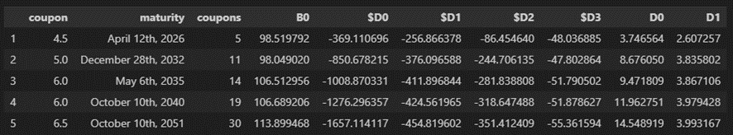

## Task C – Estimate the holdings of the hedging portfolio assuming the hedger wants to implement a self-financing hedging strategy

To hedge our portfolio, we used the following matrix equation:

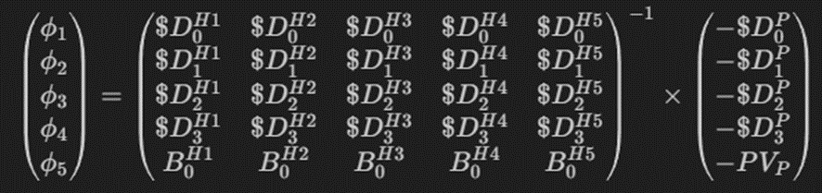

The vector first vector represents the hedge ratios assigned to each hedging instrument. The matrix represents the inverse of a matrix containing the dollar durations ($D) and bond prices (B0) for the hedging instruments. The vector comprises the negative dollar durations and the present value of the portfolio. By multiplying the inverse matrix with this vector, we obtain the optimal hedge ratios. These ratios guide us in strategically allocating weights to each hedging instrument, effectively mitigating interest rate risk in the portfolio.

Here, we construct a matrix (“*dollar_duration_matrix*”) containing the dollar durations ($D0 to $D3) for each hedging instrument. This matrix corresponds to the coefficients in the matrix equation.

This code generates a matrix (“*hedging_instruments_bond_values*”) with the bond prices (B0) for each hedging instrument. This matrix is an integral part of the overall matrix equation.

Here, we combine the dollar duration matrix with the bond values matrix, creating the complete matrix required for the inversion process in the matrix equation.

This code assembles the right-hand side vector (“*solutions*”), incorporating the negative dollar durations of the portfolio and the portfolio's present value.

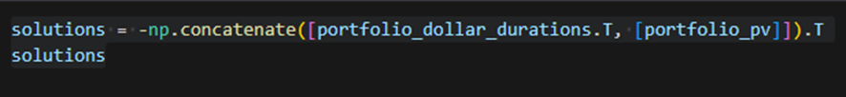

The NumPy linear algebra solver is employed to find the optimal hedge ratios (phis), representing the weights assigned to each hedging instrument:

Finally, the calculated hedge ratios are applied to the hedging instruments, and the difference between the portfolio's present value and the hedging portfolio's present value is evaluated. This difference serves as an indicator of the effectiveness of the hedging strategy.

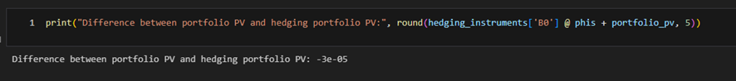

## Task D – Assuming that the yield curve changed

### Part 1 – With no hedging strategy

In response to the refined yield curve parameters, we recalculated the bond prices (B0*) for each instrument in our portfolio. This adjustment allows us to assess how changes in the yield curve impact individual bond valuations.

We enhance our understanding by visualizing the absolute percentual losses relative to maturity. The scatter plot depicts how changes in the yield curve influence various bond maturities.



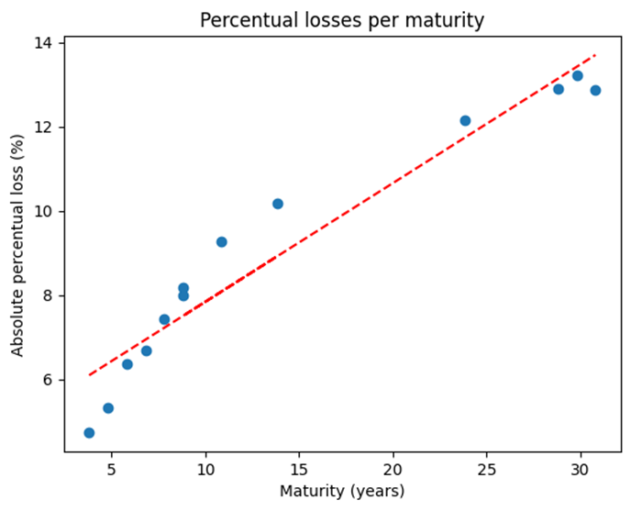

Finally, we compute the expected losses resulting from the yield curve adjustments and update the portfolio's present value accordingly. This assessment provides insights into the monetary impact of the modified yield curve on our portfolio.

### Part 2 – With hedging strategy

We extend our analysis to the hedging instruments, recalculating bond prices (B0*) under the refined yield curve parameters. This step ensures a comprehensive examination of the impact on portfolio and hedging instruments.



Incorporating the hedging instruments, we assess the overall impact on the portfolio. The code computes the portfolio loss after hedging, accounting for both bond price changes and the adjusted portfolio present value. This final measure provides a comprehensive understanding of the effectiveness of our hedging strategy in mitigating losses associated with yield curve shifts.

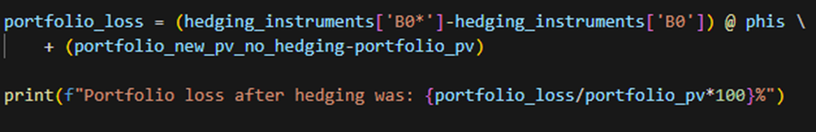

Portfolio loss after hedging was: -3094.802045919286%

The result obtained is too big and it mirrors an error made during the calculations, this error was probably when calculating the phis or the asset pricing.

# Conclusions

This analysis conducted a comprehensive evaluation of an inflation-linked bond (ILB) and a corresponding hedging strategy aimed at managing interest rate risk.

For the ILB, the assessment involved calculating accrued interest, simulating inflation scenarios, and analyzing cash flows to understand variability influenced by inflation and interest rates. Additionally, bond price distribution analysis was performed to assess interest rate risk using a specific methodology.

In parallel, the hedging strategy was developed to minimize interest rate risk by conducting a sensitivity analysis of hedging instruments and portfolio metrics. Optimal hedge ratios were computed to mitigate risk effectively, and results included key metrics such as level, slope, and curvature durations, along with dollar durations for comprehensive risk assessment.

Finally, the impact of changes in the yield curve was evaluated, both with and without the hedging strategy. Visualizations and calculations demonstrated the effectiveness of the hedging strategy in mitigating losses associated with yield curve shifts.

Overall, the analysis underscored the critical importance of robust risk management strategies in investment portfolios, particularly when dealing with complex financial instruments like ILBs. By integrating historical data, future projections, and risk assessments, investors can make informed decisions to optimize portfolio performance and minimize potential losses in dynamic market conditions.